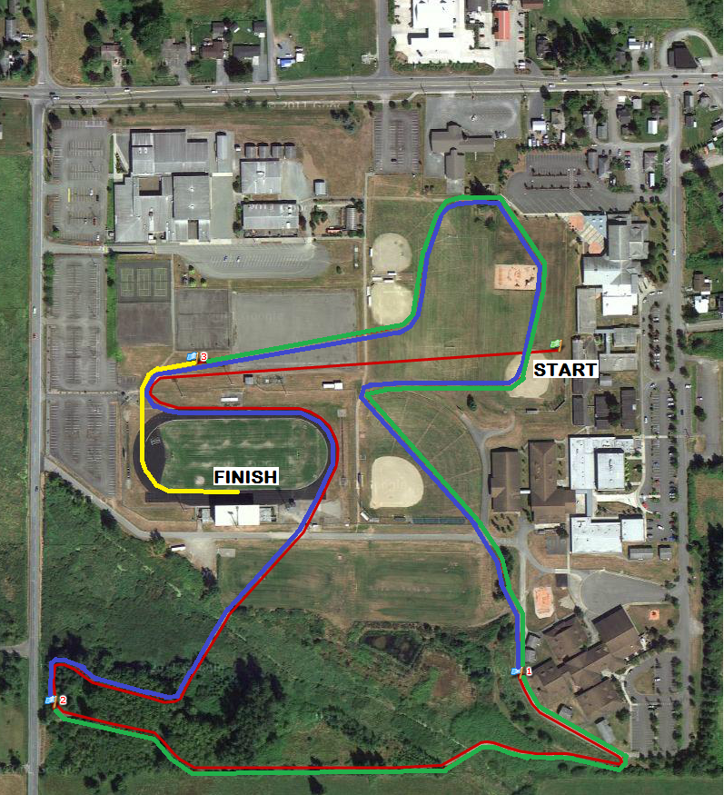

MILE 1- red
MILE 2- blue
MILE 3- green
FINISH- yellow

