2015 2B DISTRICT SOFTBALL
Tuesday, May 19 and Thursday, May 21, 2015

A. Tournament Director: Peg Seeling – La Conner HS
Email: paseeling@lc.k12.wa.us
Work Phone: 360-466-3171
Cell: 360-961-1241
Fax: 360-466-3523

B. Facilities Manager: Tom Wilfong – Stanwood HS Athletic Director
Work Phone: 360-629-1323
Fax: 360-629-1310

C. Tournament Committee:
a. Peg Seeling – Tournament Manager – La Conner HS
b. Tom Wilfong – Facilities Manager – Stanwood HS
d. Vicki Vandermay – Orcas HS

D. Participating Schools: 2 B Teams from Districts I: Concrete, Darrington, Friday Harbor, La Conner, and Orcas

E. Bracket
May 19:
Game 1 – #5 at #4 time TBD (unless #4 beat #5 twice during league play)
May 21 at Stanwood HS
Game 2: 3:00 pm (upper field) #3 vs #2
Game 3: 3:00 pm (lower field) Winner of game 1 vs #1
Game 4: 5:00 pm (lower field) Winners of games 2 and 3 play for #1 seed to
state in Yakima May 29-30, 2015.
Each game will be a 7-inning game. If needed, play extra innings to determine a winner (see below).

F. W.I.A.A. Tournament Rules:
W.I.A.A. Tournament rules will apply for sportsmanship, signs/banners, noisemakers, confetti, admissions, etc.
G. Officials:
Two (2) umpires will be assigned for each game using the NWIAA Official Allotment Criteria/Formula for determining assignments.
H. Game Balls:
Game balls will be Baden 12” 2BSFPY LEXUM, and will be provided by for the tournament.
I. Rain-out Procedure:
All games will be moved to Friday, May 22 at times to be determined. Site determination will be made and communicated to coaches at that time. In the event the tournament cannot be played due to weather or other conditions, the NWIAA emergency conditions policy will be followed to determine state representation.

J. Locker Rooms:
All teams need to come dressed and ready to play. No dressing facilities will be available.
Rest rooms will be provided.
K. Game Length/10 Run Rule:
All games are seven (7) and must be played to completion. If either team is ahead by 10 or more runs at the completion of the 5th inning, that team will be declared the winner.

- Any game ending in a tie after seven (7) innings will continue until a winner is determined or until the end of the eighth (8th) inning.
- In case of a tie game at the end of eighth (8) innings the following NFHS tie-breaker procedure will be followed: “Beginning with the ninth (9th) inning, each half-inning begins by placing a runner on second base. That runner is the player in the batting order that precedes the leadoff batter in that inning. Then the game proceeds a full inning or until a winner is determined in that inning.

M. Home Team – Visiting Team:
Home teams for games #1, #2 and #3 are pre-determined by the team placement in league with the higher seed as the home team. Home team for the final game will be determined by a coin flip.
N. Warm-ups/Pre-game
The home team will take infield/outfield 30 minutes prior to game time. The visiting team will take infield/outfield the fifteen (15) minutes prior to game time. No ground balls will be taken on the infield area prior to game time.
O. Batting Practice:
The use of whiffle balls/restricted flight balls in a soft-toss manner will be acceptable at the District Tournament. No live pitching with any ball will be allowed. Please do not hit balls against fencing.
P. Protests:
All problems concerning rules interpretation must be resolved immediately. The games committee will consist of the head umpire, tournament manager, and a tournament committee member not involved in the game in question.
Q. Players Bench:
Only uniformed players will be allowed on the team bench. As per the state guidelines, a maximum of twenty (20) players and five (5) designated personnel (coaches, managers, scorekeeper, and trainer) will be admitted.
R. Scorekeepers:
The home team’s scorekeeper will keep the official book. If the home team does not have a scorekeeper, the visiting team’s book will be the official book.
S. Admission: We will not be charging – participating schools will split the cost.
T.. Supervisors: Each participating school will need to provide one (1) school supervisor/designee for crowd control.
U. . Awards:
A first place trophy will be awarded to the tournament champion.
V. Qualifying for State
Only the top team will advance to the WIAA 2B State Tournament May 29-30 in Yakima.
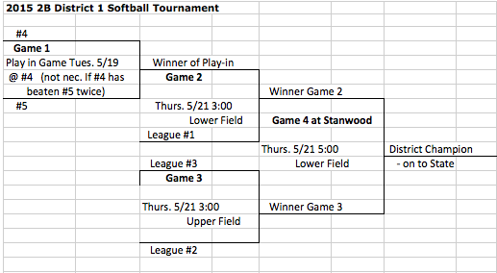

Gate Pass List for District 2B Softball Tournament

Stanwood High School, May 19 and 21

Submit by email to Peg Seeling by 3:00 p.m., Friday, May 15, 2015
paseeling@lc.k12.wa.us
School:
AD: Principal:
Players 20 Maximum | Coaches, Managers, Scorekeeper (5)

