VARSITY
# | Name | Grade
1 | Lindsey Colwell | 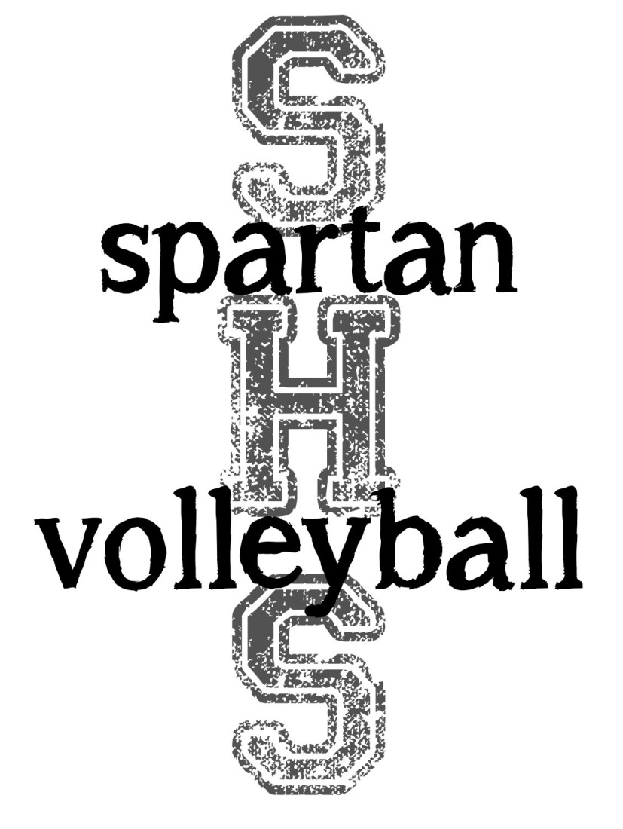  12
2 | Hayley Steinman | 12
3 | Cate Richardson | 12
4 | Michelle Passmore | 9
6 | Karissa Smith | 12
7 | Kiandra Franklin | 10
8 | Taylor Comerford | 11
9 | Kaetlynn Brown | 12
10/13 | Hannah Fitzpatrick | 11
11 | Heather Thompson | 10
12 | Kelsie Cornett | 11

JV
# | Name | Grade
1 | Georgia Hinds | 9
2 | Mallory Guglielmetti | 9
3 | Sam Durano | 11
4 | Michelle Passmore | 9
5 | Sam Petersen | 11
6 | Hannah Fox | 10
7 | Cassidy Kendall | 11
8/18 | Jessica Johnson | 11
9/17 | Brooke Beddow | 11
10 | Kiandra Franklin | 10
12 | Ashley Cueger | 9

C-Team
# | Name | Grade
1 | Jessica Lee | 9
2 | Alicia Peterson | 10  Head Coach: Mike Fitzpatrick  Assistant: Eric Stansbury  Assistant: Chris Schumacher  Assistant: Jenna Chantler  Manager: Morgan Bates  SHS Athletic Director: Jeff Baines
3 | Haley Munroe | 9
4 | Ryleigh Cobb | 9
5/16 | Kaitlyn Meath | 10
6/18 | Kristina Alderson | 10
7 | Alex Campbell | 9
8 | Olivia Alexander | 9
9 | Sydney Gusler | 9
10 | Bailey Chelemedos | 10
12 | Christina Herr | 9
14 | Sarah Wilson | 9

