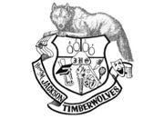

Jackson High School
2015-2016 Girls Bowling
Varsity:
Eleanor Krahn 11
Brandi Orlosky 12
Samantha Mutolo 10
Breanna Tolbert 10
Ambika Moore 12
Junior Varsity:
Mykayla Yonkoske 11
Indira Moore 09
Taylor Smock 10
Cloe Phipps 10
Camryn Summers 12
Molly Jo Myers 09
Sophie Schroeder 12
Lauryn Abbott 10

Head Coach: Dan Eng
Athletic Director: Blythe Young
Superintendent: Dr. Gary Cohn
Principal: Dave Peters
Assistant Principals: Michelle Renee
Shaun Monaghan
Blythe Young

