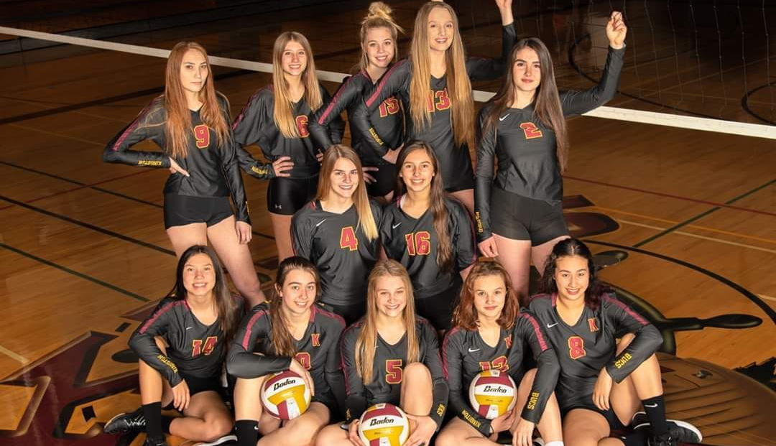
Watch for NOTES on KHS Olympic League Page
- Winter and Spring School Sports
- Club Select Sports
- Open weight room hours
- Volleyball program weight room hours
- Open Gyms (starting after Spring Break)
- Spring/Summer Pract. (Late May, June, July)
- Juneau, AK (between June 24 and 30, 2020)
- CWU Team Camp (likely week of July 5-10)
- KHS Youth & HS Camps (last 2 weeks of July)
- Tryouts projected August 24th, 2020

