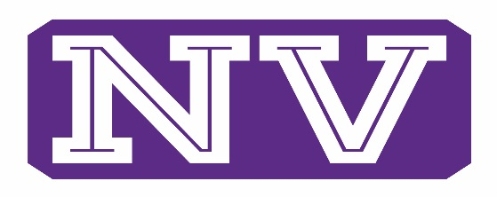
ATHLETICS

Hi,
We will be getting the opportunity starting 10/5/20, to begin Sport Specific Skill Conditioning sessions with our various athletic programs. We have this open window until 11/30/20. This time period is an adjustment from the WIAA meant to take the place of the time we missed this summer in June and July.
Specific dates and times should be developed by weeks end.
Here is what we do know:
- Each program will train 2 days a week for up to, but not over 90 minutes.
- These sessions are strictly optional. No playing time or squad selection will be connected with attendance in any way.
- All athletes will need a current valid physical. Coaches will notify any of their athletes if needs this updated.
- All athletes and coaches will need to fill out the COVID WAIVER, and COVID SCREENING FORMS. The ones from summer strength training are still valid. These are available through your coach and one our NWC NVSD Athletics page. Please look on the Bulletin Board under COVID update.
- All Athletes will need to update and fill out an Emergency Medical form. Those from 2019-2020 expired on 7/31/20
- We will do a temperature check each day. Anyone at 100.0 or higher cannot participate for at least 24 hours. We may refer them to a physician depending on other possible symptoms.
- Athletes will be only participating in one practice per day. At least in the immediate weeks.
- All activities are non-contact.
- We will be training in Pods of 5. Pods will stay together as a group all week in that specific sport. As a multi-sport athlete you will have a different pod in your other sport(s) but they will also stay together all week.
- We will not play/scrimmage other schools. WIAA stipulation.
- Please contact Coach Harmon if you have questions. 360-220-7142 tom.harmon@nv.k12.wa.us
Thanks
NVSD Athletic Program

