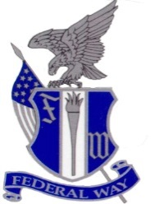

**2017-2018**

**Women’s Wrestling Schedule**

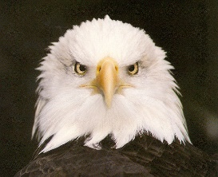

|  |  |  |
| --- | --- | --- |
| Date | Event | Location |
| October 30 | Pre Season Meeting | Meet in room 2422 |
| November 13 | First Day of Practice | Meet in front of locker room |
| ***November 20*** | ***Adopt-A-Wrestler Begins*** |  |
| November 22 | Weight Assessments | Room 2422/Training Room |
| November 23 | Turkey Day Run | Front of FWHS |
| November 29 | Blue and White Duel | FWHS |
| December 2 | Lady Jag Invite (Varsity and JV) | Emerald Ridge HS |
| December 7 | Open Wrestling Night | Thomas Jefferson HS |
| December 9 | Centralia Tiger Classic (Varsity and JV) | Northwest Sports Hub |
| ***December 15*** | ***Adopt-A-Wrestler Ends*** |  |
| December 16 | Hammerhead | Kitsap Pavilion |
| December 27 | Rogers Holiday Tournament | Stahl Jr. High |
| January 4 | Women’s Wrestling Open | Decatur HS |
| January 9 | Double Duel vs. Rogers, Yelm | Rogers HS |
| January 11 | Women’s Wrestling Open or Duel | Todd Beamer HS |
| January 12 | Picture Day | FWHS |
| January 16 | Women’s Wrestling Open or Duel  Senior Night | FWHS |
| January 20 | Lady Lipstick Invite | Lakes High School |
| January 24 | FW All City Duels TJ, TBHS, DEC | Decatur HS |
| January 27 | Lady Knights Invite | Kamiak HS |
| February 2-3 | Sub Regionals | TBD |
| February 9-10 | Regionals | TBD |
| February 15 | Practice at State | Tacoma Dome |
| February 16-17 | State | Tacoma Dome |
| February 22 | Banquet | FWHS |
|  | | | |

Number of Duals: 6

Number of Tournaments: 6

**Total Regular Season Competition Dates: 12**

**Home Event Site: Federal Way High School Gymnasium**

**Please visit** <http://www.npslathletics.org/> **for information regarding the dual meet schedule.**

**Regular Practice Times**

TBD Will post on FB and Twitter ASAP.

**Saturday and Holiday Practice Times**

8:00 a.m.-10:30 a.m.

**\*Schedule Subject to Change**

**Dr. Matt Oberst**

Principal

**Josh Agpalza**

Assistant Principal

**Randy Long**

Assistant Principal

**Khaleelah Rahsaan**

Assistant Principal

**Robin Champman**

Dean of Students

## Athletic Office

**Athletic Director:**

John Yellam

## Federal Way High School

**Mascot:** Eagles

**Enrollment:** (9-12)

**WIAA District:** 3

**League:** NPSL 4A

## Coaching Staff

**Head Coach** Travis Mango

**Asst. Coach** Maria Manzueta