North Kitsap School District No. 400

Field Trip Permission Form
(Informed Consent Form*District Curricular/Co-Curricular/Interscholastic Activities)
21101

- GENERA L INFORM ATION (return this form to your child's school before auachments for your information.)
....)z.'-\"''-'=ti:..'.1,1--l_'--t+h
and keep any

is planning a trip to ....L..-.l..-f1....-:!f..-1+. \i.r=J-A -----------------------------
P -So - Sou--'-----_b__l_l_-- P ------------
Trip destination Fi..........;\L. t-..\.:._\...r.:,-jt-"'- S-'--c_ o_I PhoneQ\eL Grl- CJ(:, -<l\()1-t

Address
5blb J.oii-.S-t. b
h \.Jr\ <\ l{l'f pJace of lodging IJ/::..A...;- _
1 1
date/time (">/ 2..6 "'"" "" - f ....
a

We will leave from j)ll r"t:'. h..tJ

Dt1•'oLL
v .

We will return to ±2S f>-D " 0 j.'
Itinerary attached {ZJ List of items needed attached
date/time _.6....../_ 17-Lr /D --5_ v - _
D

Attgm'ipg; Number of students 1_------ Number of adults
5 _

Txpe gf Trnospgrgtipp; DDistrict Vehicle
0District Bus 0Private Vehicle NO DISTRICT transportation provided

Commercial Transportation (describe) ---------
Other (descri.be) __10. 0-1'C V\1. :5
1t.) Ir 0 v ;cJ.,.rt_ +....i·if<l'

  - By signing this permission form parents/guardians accept responsibility for insuring that their student arrives to the designated
Jepartuce area on time and is pjckecJ up at the specjfied pjck up Iocatjop op time,
11. MEDICAL INFORMATION (Completed by Parent/Guardian)

Maljcal lnfgrm1tjpn;
The following special health problems should be noted and adequate precautions taken (list such items as unusually severe reaction to
bee stings, other severe allergies, hemophilia, diabetes, heart disease, etc.)

The following medications, prescriptions, or special diets are needed:

Mgdiiijl keliisc;
In the event of an accident Of" illness, I understand that reasonable effort will be made to contact the parent immediately. However, if I am not available, I authorize the school district to secure emergency medical care, as needed.

Name of preferred doctor ------------------------Phone --------------

Name of insurance carrier ------------------------Policy Number ----------

This activity provides a learning experience for the students and allows them an opportunity to apply their classroom learning. Altoougt I understand that the school district will make reasonable efforts to provide a safe environment, I am fully aware of the special dangers and risks inherent in participating in the activity. Being fully aware of the risks, I hereby give consent for my child to participate in the activity.

Parent name, please print ---------------------Home Phone-------------- Home Address & City _ Work Phone--------------

Parent/Gua..dian Signature
_.Emergency Phone -------------

NK2320F9/09

2320F-6

NORTH KITSAP SCHOOL DISTRICT
OVERNIGHT CAMP/FIELD TRIP/HEALTH FORM

STUDENTNAME-------------------------------------------------------- HEALTH INFORMATION
TEACHER/SCHOOL. -

Please fill out this form and return it to school at least one week before field trip/camp begins.

- Inform the person you have listed as an emergency contact that you are doing so. If you are unavailable for instructions in an emergency, attempts will be made to contact the other name listed. Let that person know where to contact you if you plan to be away from home for several hours.
Emergency contact: Phone----------------

If your child is taking any medication that he/she will need to bring on this trip, list the name, amount, and times to be given on the back of this page. All medications, whether prescription or over-the-counter, require a completed 3416-Fl form. (Physician's Order For Oral Medicine at School). Forms are available from your school's main office. Attach the completed form to this sheet. Ifpossible, please send only the # of doses needed for camp in the oriinal container with the name and dose listed on it. A designated person will be responsible for giving the medicine to your child while on this trip.

- List any concerns you have about your child's participation in trip activities. Feel free to discuss them with school personnel.

- Ifyour child has any allergies, list them on the back of this page. We will be glad to help you work out any special problems so that your child will be able to participate in this activity. Send a list of known allergies and a copy of specific doctor's instructions.

5. In the event of an emergency, every attempt possible will be made to contact you to discuss your child's care. If hospitalization is necessary, we will do so. Please sign the consent form so that we will be authorized to obtain emergency care if it is indicated.

5. Does your child have any problems or conditions that would exclude him/her from participating in any activities?

,...., NO ,...., YES(If yes, Please list restrictions.)

NK2320F6/0303

5. Does your child have any allergies to: (Ifyes, list and explain reaction.)

5. ls your child taking any medication that will need to be given while on this trip? If so, list names of drugs, amounts and times to be given. Attach completed 3416-F 1 -Physicians Order For Oral Medicine at School -to this sheet.

5. ls there anything else that you would like us to know about your child which will help us plan for this trip?

If my child should become seriously ill or injured while on this trip, I authorize school officials
to take him/her to the nearest hospital for emergency care, if that is indicated.

Health Notes:
Signature and Relationship to Student

rev_ 3/03mm

North Kitsap
School District

Student Health Services School Health Consultants 18360 NE Caldart Avenue Poulsbo, WA 98370
Ph: (360)

A Great Place to Live & Learn
396-3580
Fax: 1-888-784-3535

AUTHORIZATION FOR ADMINISTRATION OF MEDICATION AT SCHOOL
For 2018 2019 School Year
** THIS PORTION TO BE COMPLETED BY THE LICENSED HEALTH PROFESSIONAL {LHP} **
Name of Student: Date of Birth :----------
Reason for Medication:-------------------------------- Name of Medication: (oneper form) _
Dosage & Mode of Administration :
If given for allergic reason, describe indicators:----------------------- Time to be given: _
Inclusive dates during which medication is to be given:-------------------- Possible side ects of medication:
Action or first aid measures required if side effects occur: -------------------

Licensed Health Professional: -----------------Phone:---------
(Please Print)
Signature Date _

**THIS PORTION TO BE COMPLETED BY THE PARENT/GUARDIAN **
I request/authorize the school to administer medication to the above identified student in accordance with the LHP's instructions for a period from to (not to exceed current school year). I understand that every effort will be made by school staff to administer the medication in a timely manner, but it is possible for a dose to be delayed or missed. I will deliver the prescribed medication to the school in the original pharmacy container with the label intact. (Student may not hand carry medication to school unless it is an Epi-Pen or Inhaler and there is an Authorization for Self Administration form on file)
I agree to hold North Kitsap School District harmless for any liabilities it may incur in connection with this
requested medication at school when medication is administered in accord with LHP's written direction. School Student Attending: ---------------
Parent/Guardian Name:----------------
(Please Print)

Phone: Home Work Cell _

Parent/Guardian Signature
__ _ Date---------

n k s c h o o ls . o r g Rev. 5-01-2017

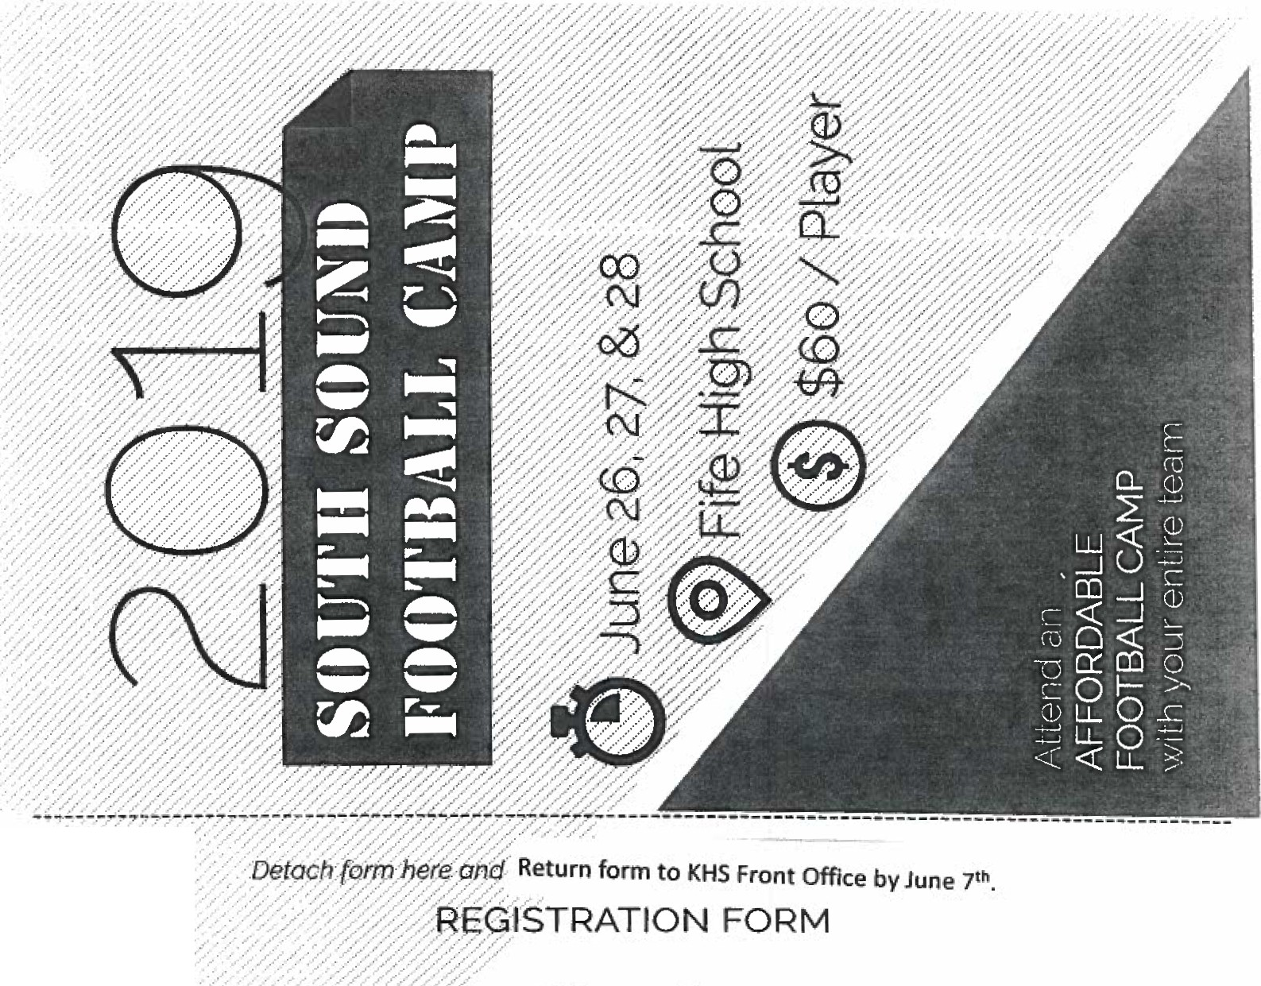
• ,1- • - ,,...
Ci\!)lp:t'$·
:...·:,.....:·...r......_.,_,..·.,..,·.-..,.....,.............·:.· ·..,·,..,·,..,....·...·, --Age: _ Team __ TShirt Size: ___

M:aj\i iAdts;·-. ':. ..:.:.: .>' >. ·> --.·>-.:-"

. . - --:.: .-'_,,. ..·.... .. .. .·-·.•' ,. ·-.r . /... . . ....>

City:-------St.ate: _ Zip:----

Holl}} pn:c.:· ...,· ·:.._'...,.··><·:.::::emergency Phone: --- ---
. ·.,..·....- .- ·.-·..·....... -,-....·•

..) . .-
·.... ·_

lher.eb.)(tlqti:or. - e·ap.pUi:at to attend SOUTH SOUND FOOTBALL CAMP and waive and release SOUTH SOUND
FO,tJr i;-.L P:: fHi.9h:SChool. the Fife Sch0<:>t Dist icl and any of theif rePfesentatlves an<:l / o< assignees. from any
ti· { itf$.:hjl¥i;.·ctaims.suits or damages which might result from participation in this act vity Iknow of no med1-
·cl,qt ysical·p.rob ms·which may affect the camper's ability to safely participate In this camp. Iauthorize the directors of
!:}1i$·cpmp·· act f()f.1,n;e·In any medical emergency according to their best judgmenlIn the event of illness or injury I
.hery rve- rny" n5ent for medical treatment andassume full <espons1b1lity for any medical expenses.
_. ... "' •'
- ant-IG dian Signature: ------------- Date:------

Enclosed is $ _
Check # _

Paid online
111$µ Company:-----------Policy #: ---------
Physician Name: Physician Phone :

A $60 feeIs due by June 7th.

Please make checks payable to Kingston High School,or you can pay by credit card onUne.

Return form to KHS Front Office by June 1t.ti.

0'
0
..c
u
Vl
..c
-
::J:
c
....,.,.
bO
c
S2
.....
..0

a.
"'
Ill
u
C1>
..c u
C1>
"E'
C1>
Ill
c"cu:'

a.i
.E
c:
0
".C...
-

-0
C..V..
u

>
..0

>
"a'.
c
"u'
::I
g_
....
0

..\..I..

l'·
C'

,_,
'e­n
0
•)
.1...1.>..
n

F
1.)
"''
•,,.,.
_)
f

c:
',_
..

.,
<ll
I '
<I!
u
e
('--)

tl\
HI c)l
,,, c
I.'I .

..,. n ·
II <fl t()
to-I t/J • I
ct) " ,;....
q,
::--· ti\ (fl fl
' ' c CJ. <I> • (])
tl; :::,,._
0 (I j .,-IIl Cl.
E
''' ' . .,, •n < i L m
{" ( ) '" ,_ ( l -·

rl .-i rl rl
co co
z rl .-i
.-i .....
o..-- Wuo_I N..... r t

..- 1 .....
.. I T...
c c
() () ('i
rl rl
rl T"i "'
....J . ('\I 1-

Ill " <]) •I> ··, ; CJ 0
w
- .. ... L> l-
°" .,
O- · tt 111

-· I"·""'• c'.>
1·1, fl)
m '.:J
_c
,...
cco
Z I- o0 w u..1 ·
0 y:.( _! C) <5 , '·
<'6 W L I IJ.
L

' 1 <It rr; Q. ! c..
ti) rC.
...J (.'.) (_'} ..._ L.-

\·1 Oc>,,-,., c O>
c 111 <I>
.::c ..c.
z I (-v 0 <( <( "> r:i
1'.) <I l -::( •fl

C- -> -
en
<J>
.,,, o· ,_ <n
() 0....... '•. 2
--' =' I)
, -,.,:,-:· ._::.-.. {,_) IT.LI

111 m -. n m · .... ti> <ll O 11>
I- I "";" ""'" :-.. , ·
IJ..1 !::.· •.1 -<-. - '
L ...... :=:
u
,...... "=5
c l.>

' I I/) . .., () ? I.) ..0
9> '
..;; IL
<'71
8
LU 0: <l C. 0: 0:: 111;L <.) C O: IX LU -1

.I.
1- w o u u c.Y.
o \ ) ( ) ( ) f_t: < )

:. !: f 0
-5 , .2 :i .....
u en r- r-... <n
t n m ..... ('"1
1 c f> 1n m < 1

'• : :-: ,':n
2\.. '
l/J
. g,
:< () ••, If) ;.._
2. 2 2 2" > > ::> > - -: ;::
<( <f '( <( Q.. CL Q_ (). Cl Cl II (I. f.l

(t\
< >
t)i r (·, 'j: {I l; '- () 3 t/l
r, \ ''' n ':-- <-J ..c. ·· O ,,._
<(
0 0Q ('I t.() l.() 1.0 (l t "> I(\ Il l < ) I.( \ 1(1

I I .. ( ) -· lj ) m
I/ )
<n cu
rl Q (\.f <-1 ._t ,-1 •,f ("I (\.f °<f ' I < > f It I

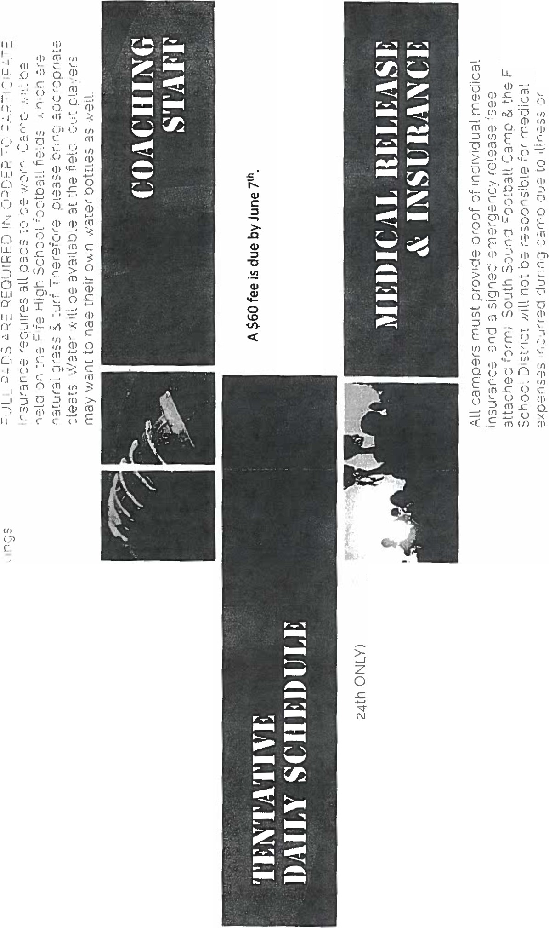I I • JI( ) ··1 "11.LI ,', n • I ..,
t
(J)
0 0 ::: ;-i 1 1 f'I "' iv i ·I I -r
.--1 rl

