Federal Way High School
Girls Swim and Dive 2019 Season
Syllabus

Contacts:
Tim Yen – Head Coach Lesley Elijah – Assistant Coach
Email: tyen@hawaii.edu Email: lelijah@fwps.org

John Yellam – Athletic Director
Email: jyellam@fwps.org

Introduction:
Girls swim and dive is a fun team and individual sport. Students have the opportunity to compete in individual races while scoring points for their team. Swimming is a non-cut sport where the athletes will learn how to swim with the proper techniques with speed and power. Athletes will also learn about the discipline and dedication that comes with the sport, all while having fun.

Requirements:
Before an athlete becomes eligible to compete at a swim meet, they must have attended a minimum of 10 practices.

Pools and Practice Times:

Marine Hills Swim and Tennis Club Federal Way Community Center
600 S 302nd Street 876 S 333rd Street
Federal Way, WA 98003 Federal Way, WA 98003

August 26-30: 4:30pm-6pm @ Federal Way Community Center

September 2nd: 8am-10am @ Marine Hills Swim and Tennis Club

September 3-6: 2:45pm-4:30pm @ Marine Hills Swim and Tennis Club

September 9-October 25: 2:30pm-4:30pm @ Federal Way Community Center

Transportation:
Transportation to practices will not always be provided. If available, it will be on a first come first serve basis as there are only 7 spots available in the van. Transportation to and from away meets will be available either through the school bus or a van driven by a coach. Parents are responsible for getting their kids to practice and home/KCAC meets.

Gear/Equipment:
All swimmers are required to have a one piece swim suit (main colors: blue or black), goggles, and caps. If available, gear will be able to be loaned. If you choose to borrow equipment, check in with one of the coaches to see if what you need to borrow is available. Borrowed items must be returned by the end of the season.

We will try to order custom Federal Way caps to use during competitions as well as suits.

Competition Scoring:
Individual Events Relays
1st – 6pts 1st – 8pts
2nd – 4pts 2nd – 4pts
3rd – 3pts 3rd – 2pts
4th – 2pts 4th through 6th – 0pts
5th – 1pt
6th – 0pts

Swim Meet Schedule
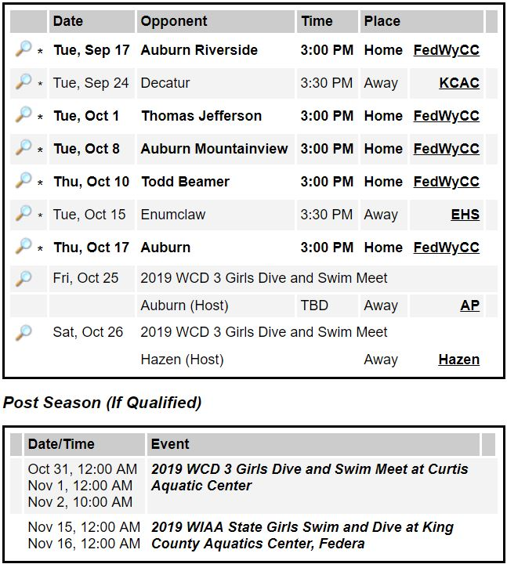

Lettering Requirements:
Swimmers must score 15 varsity scoring points throughout the season in order to letter. (See Scoring Section) Also relay points will be divided by 4 as there are 4 swimmers in that race. For example, our Federal Way A relay comes in 1st; they score 8 points and each individual swimmer will earn 2 points towards lettering.

