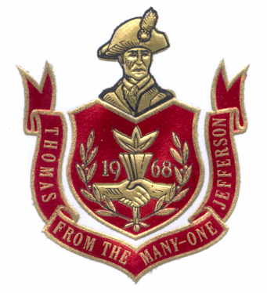

Thomas Jefferson High School
2014-2015 Lady Raiders

VARSITY
NO. NAME GRADE HEIGHT POS.
2 Aliyah Ramil 09 5’ 0” G
4 Isabelle McLarty 11 5’ 4” G
10 Iman Yusuf 12 5’ 7” F
11 Carlie Jones 10 5’ 8” G/F
15 Michaela Swiney 12 5’ 8” F
22 Madison Still 09 5’ 6” G
23 Bailey Nelson 11 5’ 7” G/F
25 Katie Hernandez 11 5’ 4” G
32 Halli McGraw 10 6’ 0” F/C
42 Julia Walker 09 5’ 10” F/C

Head Coach: Carrie DeCaires

Assistant Coach: Jessica Peterson

Manager: D’Yarah Karell

Statistician: Kristen Ybarra

JV Coach: Brooke Scheib

C Team Coach: Jake Cuaresma

Principal: Adrienne Chacon

Assistant Principals: Paul Lagerstedt, Laurie Bender, Paul Nichols
Athletic Director: Paul Lagerstedt, Jeff Zenisek
Dean of Students: Christian Storm
Band Director: Mike Lewis
Cheer Advisor: Monika Johnson
Athletic Trainer: Apple Physical Therapy

