Mount Rainier Girls Soccer Handbook 2014

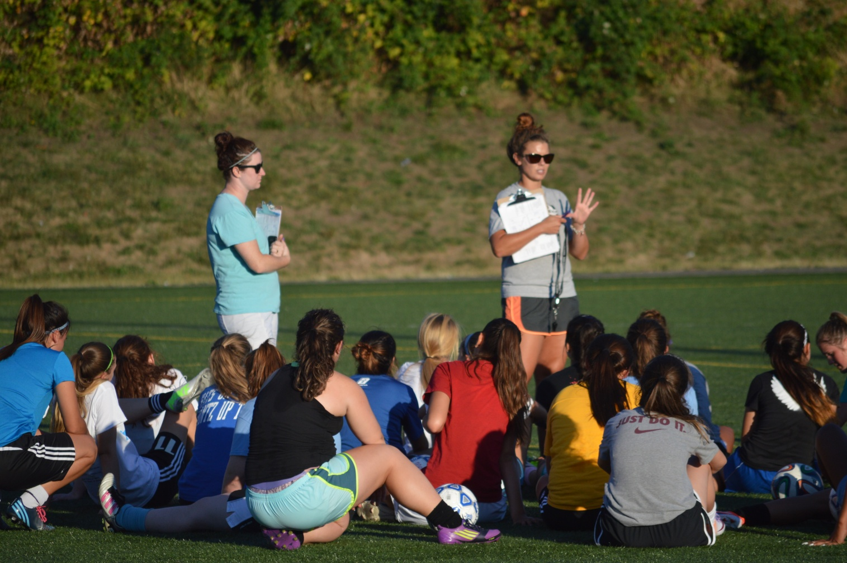

Head Coach: Michelle Mohn

“I am a member of a team, and I rely on the team, I defer to it and sacrifice for it, because the team, not the individual, is the ultimate champion” (Mia Hamm, US Women’s soccer team)

Welcome to Mount Rainier HS Girls Soccer!

The goal of Mount Rainier Girls Soccer is to help provide athletes one of the greatest High school experiences they will have! I hope to teach accountability, responsibility, unity and the importance of being a part of something bigger than thyself. We expect athletes to make a commitment to our team and work to their full potential daily. We also demand they adhere to the team policies in order to have a successful season.

Sincerely,

Michelle Mohn
Head Coach

Team Webpage: http://mrhsgirlssoccer.wix.com/mrhsgirlssoccer

Staff
Head Coach
Michelle Mohn
Cell: (253)-350-4247
Work: (206)631-5858
Michelle.mohn@highlineschools.org or Mmohn14@gmail.com

JV Coach
Julia Still
(206)316-0524
Julia.still@highlineschools.org

Assistant Coach
Courtney Cass
(206)384-7745
Courtneym.cass@gmail.com

Volunteer Assistant Coach
Mike Fuchigami
(206)769-8452
Fuchigami.wa@comcast.net

EXPECTATIONS

Academics

With the understanding that our athletes are students first, we expect them to be performing adequately in all classes at all times. WIAA (Washington Interscholastic Athletic Association) requires every student-athlete to be enrolled in and passing at least 5 of 6 classes during the current semester. Highline policy also requires students to maintain a 2.0 GPA. Initial eligibility requires these standards to be met the prior semester of school. Those not meeting the initial eligibility requirements are required to sit out from games for the first three to five weeks of the season (depending on which infraction; 3 weeks= Highline, 5 weeks= WIAA) After the three to five week period of time, if students can document they are passing 5 out of 6 classes and have a 2.0 GPA, they will regain their eligibility.

Twice during the season there will be grade checks done by the Athletic Director to verify the academic requirements continue to be met. If you do NOT attend MRHS, you will have to do an old school, paper grade check and turn it in to the Athletic Director. Those not meeting the academic standards will not be allowed to continue to compete in games until the standard is met.

Attendance:
Our team works hard Monday through Friday, on rare occasions will there be a practice or team activity on Saturdays. Therefore, athletes are expected to use the time between school and soccer to do their studying and or homework. The skill of prioritizing and managing one’s time is a valuable skill our athletes will learn. It has been one of the best skills I am thankful for having learned through playing sports. We expect the athlete to be reasonable with their commitments. Missing practice should be very rare, and the coach must always be notified in advance either in person, by email or phone.

Athletes are required to attend class on time on a daily basis. If athletes are more than 10 minutes late to class they are marked absent and will not be eligible to practice or play in a game on this day. Attendance reports are sent to coaches daily. If you know you are going to be late, or absent, make sure you have it pre-excused (by the school and Mr. Rawie) a minimum of 24 hours prior to the absence. Pre-excused absences do not affect your eligibility to practice or compete in a game.

*Athletes who miss practice the day before a game will NOT play in the following game*
Exceptions to this are at the coach’s discretion. If attendance becomes an issue for a particular player, more games will be missed and a contract will be made at that point.

Rules / Policies
- Athletes should conduct themselves in a professional way in the classroom, at practice and at games. They are expected to demonstrate sportsmanship at all times.
- Athletes travel to all away games on the bus with the team. If after a game, the parent or guardian would like to bring their athlete home, they are required to speak DIRECTLY to coaching staff before transporting their child home after a game. Parents and guardians ONLY!
- Players will wear game uniform and assigned warm up gear on game days. NO exceptions will be allowed. (No personal warm up gear on game day is allowed.)
- Always bring both sets of uniforms on game day, including socks, shingaurds and cleats/turf shoes. We will wear white at home and blue away.
- Bring running shoes to every practice.
- Gear is to be brought to and from the coach’s car and field.

Player/Parent Conduct
One of the best ways you can support your athlete is coming to watch them play. It is expected for parents and spectators to behave in a manner that is respectful and representative of Mt. Rainier! It is easy for parents to get restless during games, but please be supportive of all players and the coaching staff. Please keep the sideline coaching to a minimum, especially when we are playing games that are not in a Stadium setting. Yelling at players or referees will not be tolerated on any level. It is your job to support and cheer for the team, let the coach do the coaching.

Cont…
Parents are not allowed to talk with the coaching staff about playing time of their athlete. Athletes, however are encouraged to ask the coaching staff what they can do to improve their play time, or voice any other concerns they may have. At this level, it is important for the athlete to develop the communication skills with the coaching staff on these issues to prepare them for the next level of play, and to take responsibility for themselves. Parents please come to me, before going to the Athletic Director, if you are concerned with any issues that may be arising.

Injuries
If your athlete is injured, they are expected to be in the school training room getting treatment. Staying in constant communication with the trainer and coaching staff is required. Athletes must be cleared by the trainer and doctor prior to returning to play, if serious injury. Small injuries don’t need a doctor’s note.
Parents, please help athletes with a quick recovery process (Ice, heat, medicine, exercises and rest).

MRHS Trainer (in building)
Britini Racus
(253) 740-5277 britni.racus@highlineschools.org

Nutrition & Life Style
An important part of being a successful athlete is paying attention to and maintaining a healthy diet and life style. It is important that during the season athletes eat breakfast, lunch and dinner daily. Proper hydration is key. On game day, extra hydration in advance is advised to help reduce cramping and headaches.
Sleep is essential during the season. During sleep the body is repairing and recovering. Try to stay on a steady sleep schedule, even on weekends, during the season. This will help with the ability to recover and restore.

DRUG AND ALCOHOL:
District policy states that athletes will be suspended from further participation on the first offense (with the right to appeal). Athletes are held to this policy inside and outside of school. Please be careful with social media pictures, updates and tagging. Athletes are in the spotlight!

Lettering
-Athletes that play in 5 or more Varsity games, or play more than a total of 120 Varsity minutes will receive a letter (We will have a statistician).
-Exceptions for returning letter winners who missed part of a season due to injury.
-Athletes who complete 4 years of soccer at Mt Rainier will also letter.

Discipline
- If you miss practice you will not be allowed to play in the next game.
- If this becomes an issue, there will be a contract between player and coach.
- If you are absent or tardy you will not be able to practice or compete in a game on that day.
- If you are not working to your full potential on a regular basis, you may have extra fitness and further consequences.
- Disrespect to other players or coaches will result in meeting with coaches, captains and parents.
- Hazing will not be tolerated.
- Left gear or garbage on the field will result in fitness.

SPSL 2014-15 VARSITY SOCCER SCHEDULE
DATE | OPPONENT | TIME | PLACE
Saturday 9/6 | Jamboree | 10 am (arrive at 9) | Highline M.S.
Monday 9/8 | West Seattle | 3:30 pm | Walt Hundley
Tuesday 9/9 | Rogers (Puyallup) | 7:00 pm | Highline M.S.
Thursday 9/11 | Thomas Jefferson | 7:30 PM | Fed. Way Stadium
Tuesday 9/16 | Federal Way | 7:00 pm | Highline M.S.
Friday 9/19 | Decatur | 3:30 pm | Fed. Way Stadium
Tuesday 9/23 | Todd Beamer | 7:00 pm | Highline M.S.
Tuesday 9/30 | Tahoma | 7:30 pm | Tahoma HS
Thursday 10/2 | Kentwood | 7:30 pm | Kentwood HS
Tuesday 10/7 | Kentridge | 7:30 pm | Highline M.S.
Thursday 10/9 | Kent Meridian | 3:30 pm | French Field
Tuesday 10/14 | Kentlake | 7:30 pm | Highline M.S.
Thursday 10/16 | Thomas Jefferson | 5:30 pm | Mt.Rainier
Tuesday 10/21 | Federal Way | 5:30 pm | Fed. Way Stadium
Thursday 10/23 | Decatur | 7:30 pm | Mt. Rainier
Tuesday 10/28 | Todd Beamer | 5:30 pm | Fed. Way Stadium

2014-15 Mount Rainier Varsity Girls Soccer Schedule

 | Date | Opponent | Time | Place
 | Sat, Sep 6 | Highline SD Jamboree
 |  | Highline (Host) | 10:00 AM | Away | Hiln Mem
 | Mon, Sep 8 | West Seattle | 3:30 PM | Away
 | Dismiss: 1:40 Depart: 2:00 Return: 5:30
 | V only (Walt Hundley Field 6920 34th Ave SW Seattle 98126)
 | Tue, Sep 9 | Rogers (Puyallup) | 7:00 PM | Home | HiMemStd
* | Thu, Sep 11 | Thomas Jefferson | 7:30 PM | Away | FedWay
 | Depart: 6:00 Return: 9:30
* | Tue, Sep 16 | Federal Way | 7:00 PM | Home | HiMemStd
* | Fri, Sep 19 | Decatur | 3:30 PM | Away | FedWay
 | Dismiss: 1:40 Depart: 2:00 Return: 6:00
 | JV and V traveling together
* | Tue, Sep 23 | Todd Beamer | 7:00 PM | Home | HiMemStd
* | Tue, Sep 30 | Tahoma | 7:30 PM | Away | Tahoma
 | Depart: 4:00 Return: 9:30
 | JV and V travel together
* | Thu, Oct 2 | Kentwood | 7:30 PM | Away | KWHS
 | Depart: 4:00 Return: 9:30
 | JV and V travel together
* | Tue, Oct 7 | Kentridge | 7:30 PM | Home | HiMemStd
* | Thu, Oct 9 | Kent Meridian | 3:30 PM | Away | French
 | Dismiss: 1:40 Depart: 2:00 Return: 5:30
 | JV and V travel together
* | Tue, Oct 14 | Kentlake | 7:30 PM | Home | HiMemStd
* | Thu, Oct 16 | Thomas Jefferson | 5:30 PM | Home | MRHS
* | Tue, Oct 21 | Federal Way | 5:30 PM | Away | FedWay
 | Dismiss: 1:40 Depart: 2:00 Return: 7:30
 | JV and V travel together
* | Thu, Oct 23 | Decatur | 7:30 PM | Home | MRHS
* | Tue, Oct 28 | Todd Beamer | 5:30 PM | Away | FedWay
 | Dismiss: 1:40 Depart: 2:00 Return: 7:30
 | JV and V travel together

Post Season (If Qualified)
 | Date/Time | Opponent | Place / Result
 | Nov 5 - Nov 9 | 4A Bi-District at
 | Nov 11 - Nov 23 | 4A State at Sparks Stadium

Mount Rainier Junior Varsity Girls Soccer Schedule

 | Date | Opponent | Time | Place
 | Tue, Sep 9 | Rogers (Puyallup) | 7:00 PM | Home | MRHS
* | Thu, Sep 11 | Thomas Jefferson | 3:15 PM | Away | SLP
 | Depart: 2:00 Return: 5:30
* | Tue, Sep 16 | Federal Way | 7:00 PM | Home | MRHS
* | Fri, Sep 19 | Decatur | 3:15 PM | Away | Sag
 | Dismiss: 1:40 Depart: 2:00 Return: 6:00
 | JV and V traveling together
* | Tue, Sep 23 | Todd Beamer | 7:00 PM | Home | MRHS
* | Tue, Sep 30 | Tahoma | 5:30 PM | Away | Tahoma
 | Depart: 4:00 Return: 9:30
 | JV and V travel together
* | Thu, Oct 2 | Kentwood | 5:30 PM | Away | KWHS
 | Depart: 4:00 Return: 9:30
 | JV and V travel together
* | Tue, Oct 7 | Kentridge | 7:00 PM | Home | MRHS
* | Thu, Oct 9 | Kent Meridian | 3:30 PM | Away | Wilson
 | Dismiss: 1:40 Depart: 2:00 Return: 5:30
 | JV and V travel together
* | Tue, Oct 14 | Kentlake | 7:00 PM | Home | MRHS
* | Thu, Oct 16 | Thomas Jefferson | 3:30 PM | Home | MRHS
* | Tue, Oct 21 | Federal Way | 3:15 PM | Away | Sag
 | Dismiss: 1:40 Depart: 2:00 Return: 7:30
 | JV and V travel together
* | Thu, Oct 23 | Decatur | 5:30 PM | Home | MRHS
* | Tue, Oct 28 | Todd Beamer | 3:15 PM | Away | Saghalie
 | Dismiss: 1:40 Depart: 2:00 Return: 7:30

