2019 PHS Water Polo Game Suits

- Team suit is required – you can still use your suit from last year if you don’t want additional costs.
- Cost: $50 – cost is to the players because you keep the suit (Not returned at the end of the season) – Check or cash
  - Checks Payable to: Peninsula Boys Water Polo
- Order Date 8/30/19 – Please return to Matt Nesbit by 8/30/19

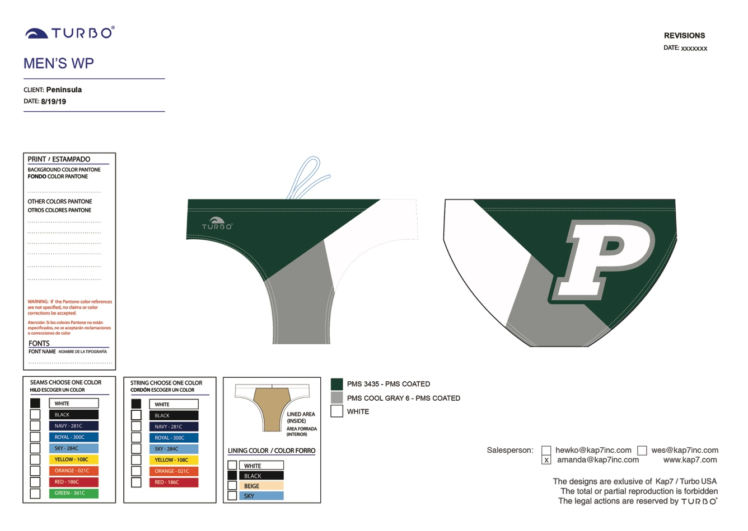

Name: ________________________________

Size (S,M,L, etc.): ______________

Check or Cash

