 | RENTON SCHOOL DISTRICT No. 403  SPORTS CAMP PERMISSION FORM  This permission form is for use with respect to district-sponsored activities with coaches and/or advisors who are district employees, and which meet district guidelines.  Student Name: ___________________________________________________________  School: _______________________________ Birthdate: _________________________  Address: ________________________________________________________________  City: _____________________________________ WA Zip: ____________________  E-mail: _________________________________________________________________  Phone: __________________________________  Dad’s Name: ______________________________ Work #: ______________________  Mom’s Name: _____________________________ Work #: ______________________  Please indicate experience level with sport: Beginner Intermediate Advanced  Student’s Physician:_______________________________________________________  Physician Phone: ______________________________  Insurance Company name: ________________________________________________  Policy/ID No: _____________________________  Group No: _______________________  Permission/Advice of Risk/Medical Release  I hereby verify that ___________________________________________ is healthy enough for school sports, and has my permission to participate in the camp indicated above.  While we take every precaution to minimize the risk of injury, we are always concerned about the risk of injury inherent in sports. Your signature below indicates that you have been advised of the risk of injury that you assume the risk, and you fully understand that you are legally responsible for any medical expenses resulting from participation in this sports camp.  If I cannot be reached in the event of an emergency, I ______________________________ (parent/guardian name, please print), authorize all diagnostic, medical, surgical and hospital procedures as may be prescribed by a treating physician for my student.  Parent/Guardian Signature: __________________________________ Date: ___________ |  |  |  |  | Renton School District #403  Concussion and Head Injury Information Sheet  A concussion is a brain injury and all brain injuries are serious. They are caused by a bump, blow, or jolt to the head, or by a blow to another part of the body with the force transmitted to the head. They can range from mild to severe and can disrupt the way the brain normally works. Even though most concussions are mild, all concussions are potentially serious and may result in complications including prolonged brain damage and death if not recognized and managed properly. In other words, even a “ding” or a bump on the head can be serious. You can’t see a concussion and most sports concussions occur without loss of consciousness. Signs and symptoms of concussion may show up right after the injury or can take hours or days to fully appear. If your child reports any symptoms of concussion, or if you notice the symptoms or signs of concussion yourself, seek medical attention right away.  Symptoms may include one or more of the following: Signs observed by teammates, parents and coaches include:  Headaches “Pressure in head” Nausea or vomiting Neck pain Balance problems or dizziness Blurred, double, or fuzzy vision Sensitivity to light or noise Feeling sluggish or slowed down Feeling foggy or groggy Drowsiness Change in sleep patterns Amnesia “Don’t feel right” Fatigue or low energy Sadness Nervousness or anxiety Irritability More emotional Confusion Concentration or memory problems (forgetting game plays) Repeating same question/comment Appears dazed Vacant facial expression Confused about assignment Forgets plays Is unsure of game, score, or opponent Moves clumsily or displays incoordination Answers questions slowly Slurred speech Shows behavior or personality changes Can’t recall events prior to hit Can’t recall events after hit Seizures or convulsions Any change in typical behavior or personality Loses consciousness  What can happen if my child keeps on playing with a concussion or returns to soon?  Athletes with the signs and symptoms of concussion should be removed from play immediately. Continuing to play with the signs and symptoms of a concussion leaves the young athlete especially vulnerable to greater injury. There is an increased risk of significant damage from a concussion for a period of time after that concussion occurs, particularly if the athlete suffers another concussion before completely recovering from the first one. This can lead to prolonged recovery, or even to severe brain swelling (second impact syndrome) with devastating and even fatal consequences. It is well known that adolescent or teenage athlete will often under report symptoms of injuries. And concussions are no different. As a result, education of administrators, coaches, parents and students is the key for student-athlete’s safety.  If you think your child has suffered a concussion  Any athlete even suspected of suffering a concussion should be removed from the game or practice immediately. No athlete may return to activity after an apparent head injury or concussion, regardless of how mild it seems or how quickly symptoms clear, without medical clearance. Close observation of the athlete should continue for several hours. The new “Zackery Lystedt Law” in Washington now requires the consistent and uniform implementation of long and well-established return to play concussion guidelines that have been recommended for several years:  “a youth athlete who is suspected of sustaining a concussion or head injury in a practice or game shall be removed from competition at that time”  and  “…may not return to play until the athlete is evaluated by a licensed heath care provider trained in the evaluation and management of concussion and received written clearance to return to play from that health care provider”.  You should also inform your child’s coach if you think that your child may have a concussion. Remember it’s better to miss one game than miss the whole season. And when in doubt, the athlete sits out.  For current and up-to-date information on concussions you can go to:  http://www.cdc.gov/ConcussionInYouthSports/  http://www.wiaa.com/ConcussionManagementGuidlines.htm  __________________________________________________________  Student-athlete Name Printed  _____________________________________________________________________________  Student-athlete Signature Date  __________________________________________________________  Parent or Legal Guardian Name Printed  ______  Parent or Legal Guardian Signature Date |  |  | MAT WARRIORS ADVANCED TECHNIQUE WRESTLING CAMP  PRESENTED BY:  HAZEN HIGH SCHOOL WRESTLING  DATE:  JUNE 26-JUNE 30  PLACE:  HHS MAIN GYM  WHO:  8th-12th GRADE  HAZEN HIGH SCHOOL  1101 HOQUIAM AVE  RENTON, WA 98059  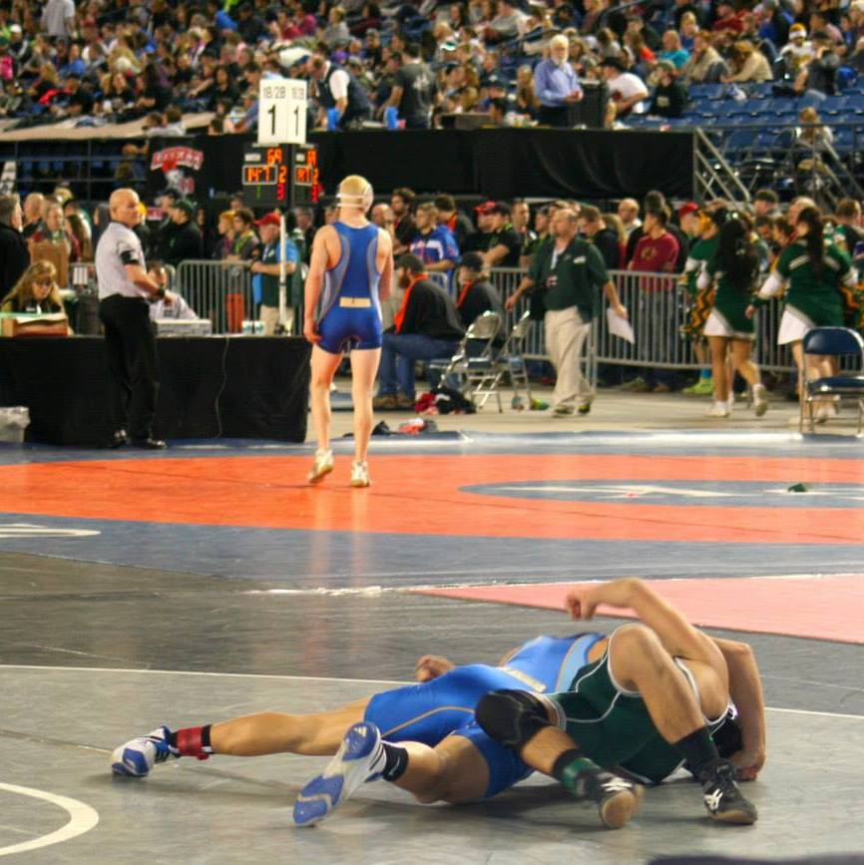

COST: $75 (PRIOR TO JUNE 1) $90 (AFTER JUNE 1)  BONUS: RECEIVE A HAZEN WRESTLING T-SHIRT IF REGISTERED BY JUNE 1, 2017  PRE-REGISTRATION AND PAYMENT BY MAIL IS ENCOURAGED. EARLY REGISTRATION PRICING CONCLUDES ON JUNE 1, 2017 HOWEVER PRE-REGISTRATION WILL CONTINUE BY MAIL UP TO THE BEGINNING OF CAMP. ON SITE REGISTRATION WILL BE ALLOWED IF NECESSARY.  Hazen Wrestling Camp permission form and payment must be sent to:  Rory Magana  c/o: Hazen High School  1101 Hoquiam Ave  Renton, WA 98059  MAKE CHECKS PAYABLE TO: HAZEN HIGH SCHOOL WRESTLING  For questions or financial assistance please contact: Rory Magana  360.632.3563  Rory.magana@rentonschools.us |  |  | Camp Mission Statement:  This camp will place an emphasis on development of higher level wrestling technique, while also giving wrestlers the opportunity to refine fundamentals. Athletes will be provided with six sessions in three days of wrestling. While learning and refining technique will be the main focus of camp, wrestlers will have the opportunity to apply new skill to live and situational wrestling. Guest clinicians will present college level technique used at the highest levels of folk-style wrestling.  Directions to the Hazen Gym:  Enter through the main entrance on the pool side of the building. Walk straight down the hallway past the women’s locker room (on the right), the main gym entrance will be on the right hand side of the hallway.  What to bring:  - Wrestling Shoes  - T-shirt (x2 per day)  - Athletic Shorts (x2 per day)  - Shower Toiletries (Shower Available)  - Water Bottle  - Sack Lunch  Wrestler Name:_______________________________________  Parent Name:_________________________________________  Daytime Phone:_______________________________________  Valid Email Address:_________________________________  Adult T-Shirt Size:_______________  PLEASE RETURN PRIOR TO JUNE 1: ENCLOSE PAYMENT ALONG WITH REGISTRATION FORM |  |  | 2017 CLINICIANS TBD- PREVIOUS CAMP CLINICIANS HAVE INCLUDED:  - 3x NJCAA/DII All American- Aaron Smith  - 4x D1 NCAA Qualifier/ NCAA D1 ALL-AMERICAN- SHANE ONUFER  - NCAA D1 All-American/HCC Head- Coach Scott Norton  - NCAA D3 Wrestler Jahleel Vester  DAILY SCHEDULE (SUBJECT TO CHANGE)  DAY 1- JUNE 28  SESSION 1- 9-11 AM- Advanced Neutral Wrestling  LUNCH BREAK  SESSION 2- 12:30-2:30 PM- Technique session  DAY 2- JUNE 29  SESSION 1- 9-11 AM-Advanced Top/Bottom Wrestling  LUNCH BREAK  SESSION 2- 12:30-2:30 PM- Technique session featuring  DAY 3- JULY 30  SESSION 1- 9-11 AM- Technique Session featuring: Norton  LUNCH BREAK  SESSION 2- 12:30-2:30 PM- Combative Wrestling

