Washington Technique Camp
Northwest University
Kirkland, Washington
July 28 - August 1, 2018
$479 Dorm Resident | $349 Commuter

Camp Details
- Camp Fee (including deposit): $479 Dorm Resident | $349 Commuter
- Deposit (due at registration): $150
- Room Key/Meal Card Deposit: $70
- Round-Trip Shuttle Fee: $40 ($80 if flight arrives after 1:30pm)
- Account Set-Up & Registration Fee: $7
- First Day to Register: December 6, 2017
- Last Day to Register: July 27, 2018
- Register Now: JROB WASHINGTON CAMP Search

Washington Technique Camp Directors

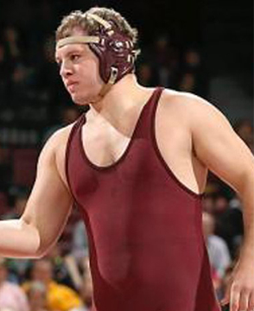 | 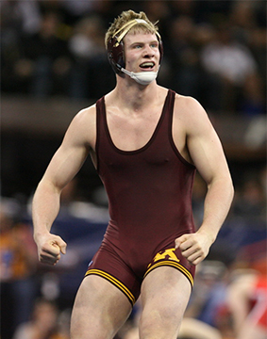
Michael Kroells  3X NCAA All-American  University of Minnesota | Brett Pfarr  NCAA Semifinalist  2X NCAA All-American  University of Minnesota
- The JROB Technique Wrestling Camp in Washington will take place from July 30 - August 3, 2017, at Northwest University in Kirkland, Washington. Northwest University is approximately 10 miles to the east of Seattle, just off of highway 405 adjacent to Bridle Trails State Park. This year's camp directors will be two-time NCAA All-American and 2017 finalist Brett Pfarr, and three-time All-American Michael Kroells.

