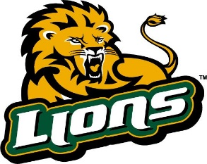  LIONS  WRESTLING  LYNDEN  VS  Mount Baker  Jan. 8, 2020  Lynden HS  1201 Bradley Road  Lynden, WA 98264  Principal  Ian Freeman  Athletic Advisor  Mike McKee  Head Coach  Hans Henderson  Asst. Coaches  Daren Oostra  Frankie Gallegos  Dane Welch  Randy Anderson  Jake Jarvis  Payton Scott  Managers  Dallana Marquez  Aaliyah Diaz | Wt | VARSITY |  | JUNIOR VARSITY |  | C-TEAM
 |  | Name | Grade | Name | Grade | Name | Grade
 | 106 | Kaleb Oostra | 9 | Ian Rodriguez | 10
 | 113 | Favian Chavez | 12
 | 120 | Adonai Lara | 9 | Kauzen Cabral | 9
 | 126 | Heriberto Cruz | 12 | Ignacio Rodriguez | 10
 | 132 | Kole Antypas | 10 | Connor Holgate | 10
 | 138 | Adrian Bueno | 11 | Edgar Antonio | 10
 | 145 | Samuel Moormeier | 10
 | 152 | Cooper Treat | 9 | Santiago Lopez | 9
 | 160
 | 170 | Bodie Human | 12
 | 182 | David Hernandez-Medina | 10
 | 195 | Li Einfeld | 11
 | 220 | Maninderpal Jassar | 11
 | 285 | David Hernandez-Solano | 9

